Annie Runnion – Director of Shelter Operations
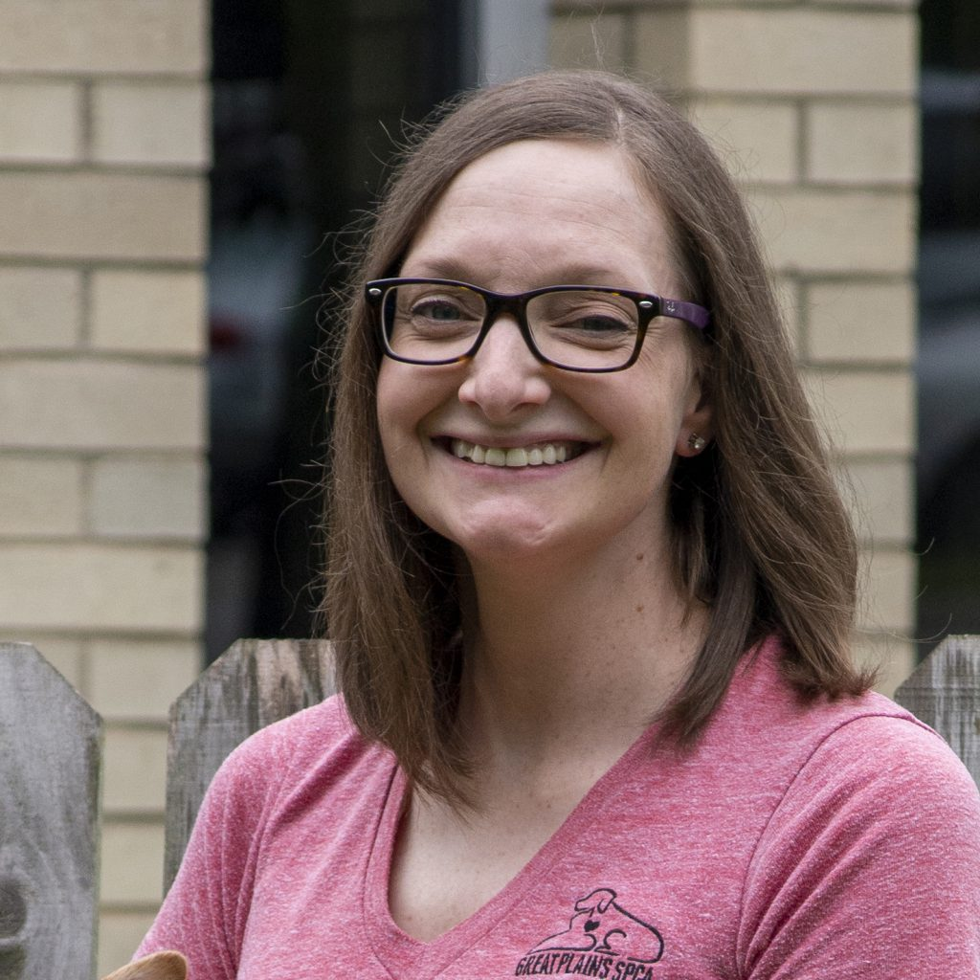
Annie Runnion joined the Great Plains SPCA family in 2012 and developed a wide breadth of animal welfare knowledge in various managerial roles prior to being promoted to Director of Shelter Operations. A Kansas native, Annie is dedicated to improving the lives of pets and people within our community.
She studied General Arts at Seattle Pacific University in Seattle, Washington and began her career in Retail Management in Merchandising. Annie has owned many animals in her life, and she now resides in downtown Kansas City, Missouri with her husband and two Great Plains Alumni dogs, Nanook and Gidget.

