Alyx Hubler – Chief Financial Officer
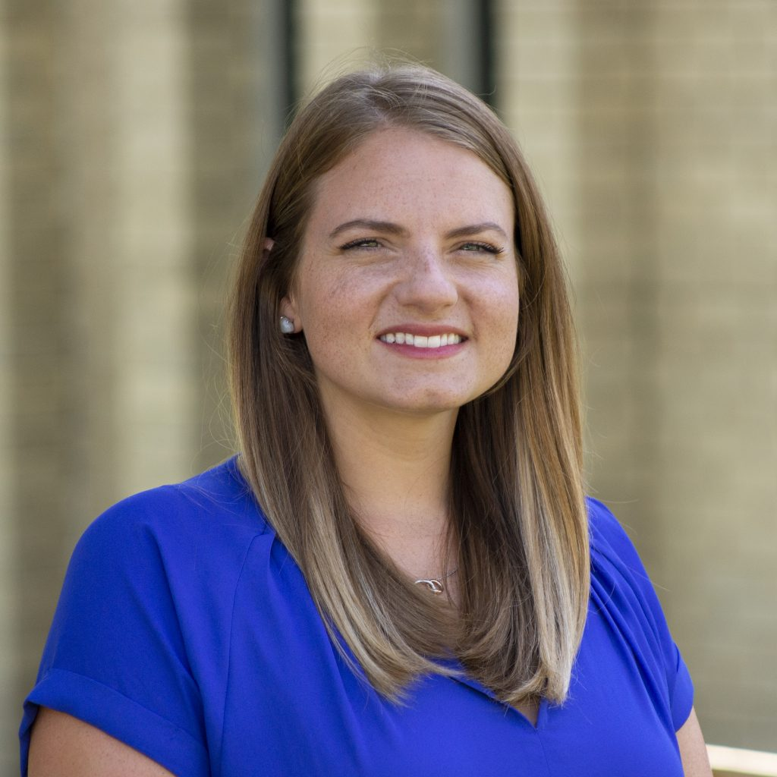
Alyx Hubler is a licensed CPA and earned her Bachelor’s and Master’s degrees in Accounting at the University of Kansas. Prior to being hired as Chief Financial Officer at Great Plains SPCA, Alyx was the Controller at Tradebot Systems, Inc., a technology based financial trading company. She started in public accounting as an Auditor at Grant Thornton.
A Shawnee, Kansas native, Alyx began as a volunteer at Great Plains in 2012 and was a member of the Young Professionals Board, but her history with Great Plains goes back to her first family dog, who was adopted from Animal Haven in 1989. Her volunteer experience includes the adoption of her first foster and late epileptic dog, Ellie. Her current household consists of her husband Thad, daughter Edie, dog Trooper and cats Penny and Luna. In her free time, she likes to travel, cook, garden, work out and play sports.

